Student Name: Nancy Sarange Mainga
Admission Number: BIT/2025/32683
School: Computing and Informatics
Academic Year: 3RD
Semester: 1
Lecturer: Michael Nyoro
Phone Number: 0112127599

WEEK 7
TASK 1
Storage Method | Advantages | Disadvantages
Shared Preferences | Simple key-value API; fast for small data; good for settings/flags/login state; no setup needed | Only stores primitives (String, int, boolean, float, long); not for structured/relational data; not encrypted by default; gets messy at scale
SQLite | Structured, relational data; supports complex queries  (JOIN, WHERE, ORDER BY); handles large datasets efficiently; ACID-compliant; works offline | Requires schema design and SQL knowledge; more boilerplate (helper classes, migrations); no built-in sync across devices
Firebase | Real-time sync across devices; cloud-based (data survives app uninstall); built-auth, hosting, offline caching; scales automatically | Requires internet for live sync; costs scale with usage; less control over data structure (NoSQL for Firestore/Realtime DB); vendor lock-in
Internal Storage | Private to the app (other apps can’t access); good for files (images, JSON, logs, cache); no permissions needed | Manual file I/O (read/write/parse yourself); no built-in querying; data lost if app is uninstalled; not ideal for structured/relational data

TASK 2: STUDENT DATABASE DESIGN
Field Name | Data Type | Constraint
Student_id | INT/VARCHAR (10) | PROMARY KEY, NOT NULL, AUTO_INCREMENT (if INT)
name | VARCHAR (50) | NOT NULL
course | VARCHAR (50) | NOT NULL
year | INT | NOT NULL (e.g.,1-4)
Phone_number | VARCHAR (15) | UNIQUE, NOT NULL

SQL:
CREATE TABLE Student (
Student_id VARCHA (10) PRIMARY KEY,
name VARCHAR (50) NOT NULL,
course VARCHAR (50) NOT NULL,
year INT NOT NULL,
Phone_number VARCHAR (15) UNIQUE NOT NULL
);

TASK 3:
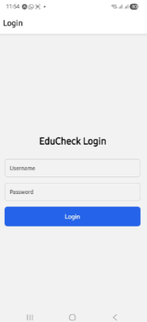



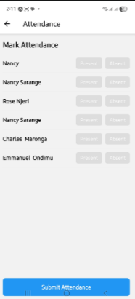
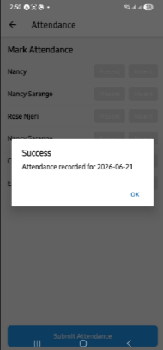
TOOLS USED
-VS Code
-Expo/Expo Go
-Expo-sqlite
-React Navigation
-Xampp/phpMyAdmin

PERSONAL REFLECTION
Developing EduCheck’s attendance module extended my SQLite work. Debugging taught me navigation registration requires imports and Stack.

